**ANALYSIS REPORT**

**2019 PARLIAMENTARY ELECTIONS OF**

**INDIA**

(Prepared by Vavilapalli Satyam Naidu)

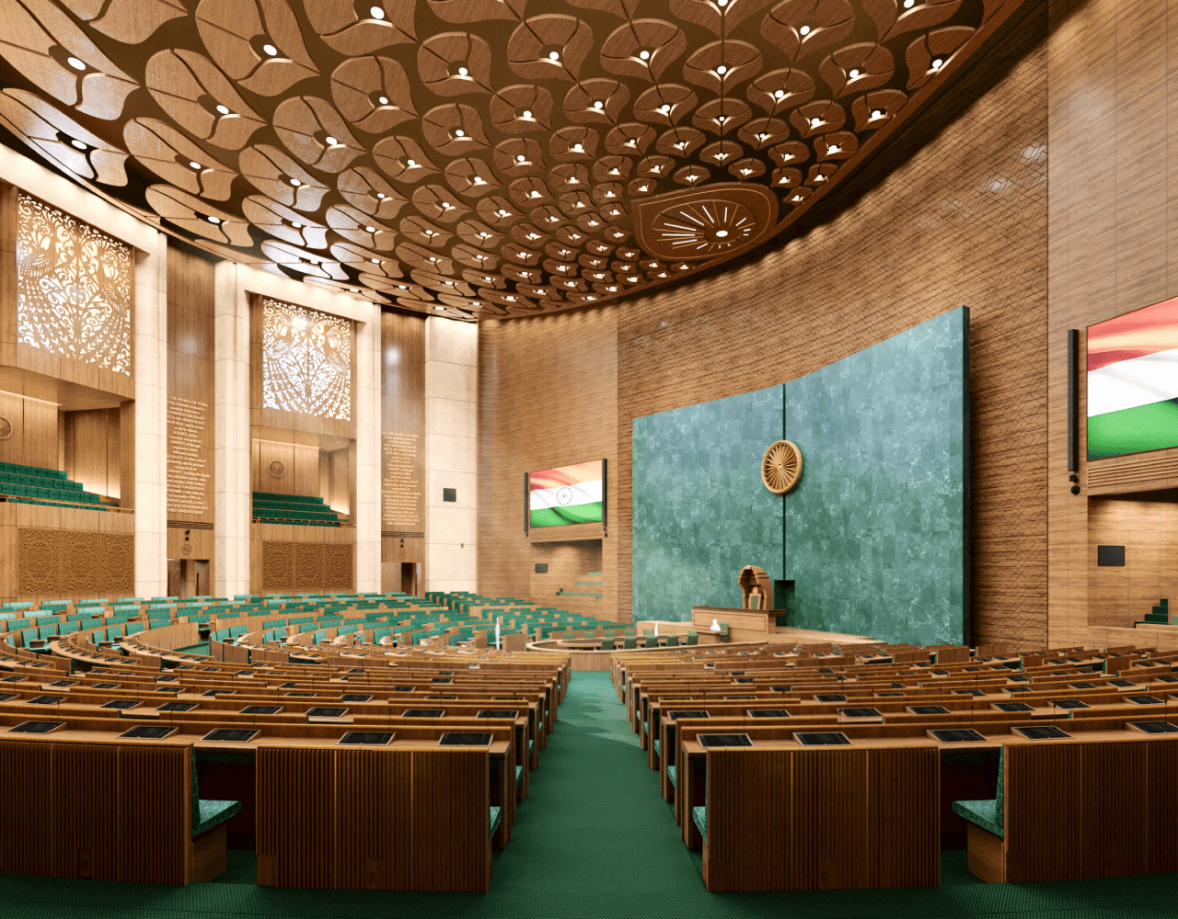

**TABLE OF CONTENTS**

**Contents Page**

Introduction 3

Purpose of Analysis 3

Questions for Analysis 4

Data Sources 5

Pre-Analysis Readings 5

Analysis Outcomes 6

1. Voter Turnout 7

2. Mandate of Elected Representatives  10

3. Gender of the Elected and Nominees 13

4. Age of the Politicians 17

Conclusion  20

References 20

**Introduction**

**India**, with an estimated population of approximately **140 crore people in 20231** (according to the World Bank), stands as the world’s most populous country, thereby making it a compelling case for understanding the nation’s governance and the processes at place to select/elect their leaders.

**The Constitution of India2 (COI)** provides for a **Democratic** polity as enshrined in its Preamble wherein the sovereignty resides with “We the people of India”, governed by their representatives elected every **5** **years**.

The responsibility to conduct general elections for electing the representatives’ vests with an Independent constitutional body called as the **Election Commission of India (ECI)**. The exercise of conducting elections for such a huge electorate is a challenging task, which requires meticulous planning and co-ordination. Since 1947, has been conducting elections regularly in a “**Free and Fair**” manner, making India a functional democracy. However, there have been frequent debates on the electoral process and its outcomes, and how it can be changed for the better.

**Purpose of Analysis**

The analysis aims to **address some of the** **contentious questions** regarding the electoral process and its outcomes. It seeks to shed light on these issues by relying on data from the latest parliamentary general elections held in 2019 to elect the members of the 17th Lok Sabha. The areas of analysis are restricted to the questions on voter turnout, gender and age dynamics of the elected representatives and the electorate, as well as vote share and electorate share of elected members.



**Questions for Analysis**

1. What is the overall **voter turnout rate** in elections and its break up among the genders? Are there reasons for a low voter turnout rate if any and what are its consequences? What reforms could enhance electoral participation?
2. Do elected representatives genuinely possess the majority **mandate of both the electorate and voters**? If not, what factors contribute to this, how does it impact the electoral outcomes?
3. What is the **gender composition of the elected representatives and contestants**? Does the Indian polity adequately represent all genders? If not, what are the reasons, how can it become more inclusive?
4. What is the **age distribution of the Indian politicians,** and what is the level of the youth participation in politics?

**Data Sources**

* Constituency Wise Details of 2019 Elections from ECI [website](https://eci.gov.in/files/file/13539-33-constituency-wise-detailed-result/).
* Voter Turnout details of 2019 Elections from ECI [website](https://eci.gov.in/files/file/13579-13-pc-wise-voters-turn-out/).

**Pre-Analysis Readings**

Before delving into the data, it is essential to grasp some of the salient features of the Indian electoral system as provided in the **Constitution of India2** and the **Representation of People’s Act (RPA)3,** which are relevant for carrying out the analysis. Additionally, understanding the **administrative structure1** of the Indian state and its **electoral divisions4** is crucial for deriving meaningful insights.

**Salient features of the Indian electoral system**

* **Universal Adult Franchise:** Any citizen above the age of 18 years is eligible to register and cast their vote.
* **First Past the Post System:** The candidate who receives the maximum votes is declared as the winner of that constituency.
* **Multi-Party System:** Any number of candidates can contest in the elections, either representing a party or independently.
* **Nomination eligibility:** Any citizen above the age of 25 years is eligible to file their nominations subject to other provisions.

**Administrative and Electoral Divisions of the Indian state**

* States: **29**
* Union territories: **7**
* Electoral Constituencies: **543**

The constituencies are reserved as shown for **Scheduled Castes** (SC) and **Schedules Tribes** (ST) to ensure adequate representation of them.

**Analysis Outcomes**

The data from the aforementioned sources has been cleaned, transformed, analysed and was finally translated into a [**Power BI dashboard**](https://github.com/Satyam122394/2019-Parliamentary-Election-Analysis/blob/main/2019_election_analysis.pbix) to visualize various metrics, integrated with map of each constituency. Subsequent sections of this report include data visuals from the dashboard with appropriate modifications.

 In addition to the insights derived from the analysis, the report also provides possible reasons for the problems identified and relevant suggestions for reforming the electoral process in their respective subheadings.



**1.** **Voter Turnout**

India has an electorate of **91.2 crore** (above18 years of age), of which only **61.4 crore** people have casted their vote in the 2019 parliamentary elections, which translates to an overall **voter turnout rate** of **67.3%** at the national level**.**

The breakup of the voter turnout and proportion (refer Fig.1) of votes among various genders is as below.

* **Male** turnout is **67.9%** or **31.72** crore voters.
* **Female** turnout is **67.8%** or **29.46** crore voters.
* 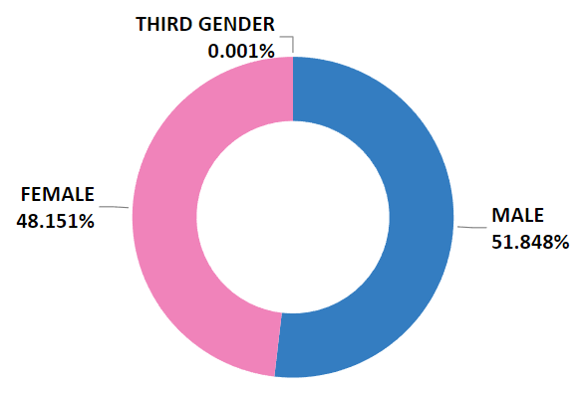**Third Gender** turnout is **17.6%** or **5,721** voters.

**Fig.1: Proportion of votes polled by gender**

**Fig.2: Voter turnout rates of all constituencies across the country**

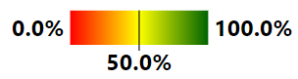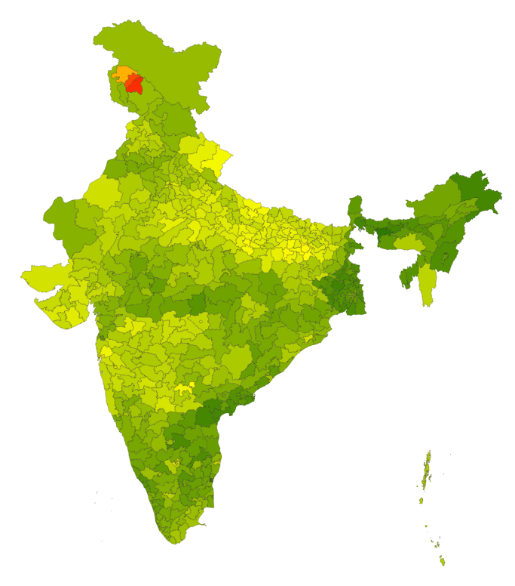

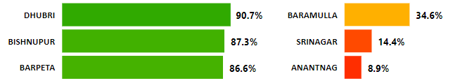**Fig.3: Top 3 constituencies with highest and lowest voter turnout**

**Key Observations**

* The voter turnout rate is considered to be on the **lower side** as the country witnessed participation of only two-thirds of the electorate in the voting process. This raises serious concernson the **electoral outcomes** and also on the mandate of the elected members (which will be further analysed in the following parts).
* Though the turnout rates and vote share of both male and female voters is similar, the **low turnout rate and unrepresentative vote share of the third genders** paints a grim picture on gender inclusive nature of the voting process. It is to be noted that the count of the registered third gender voters is far less than their eligible numbers.

**Possible reasons**

* One of the main reasons for low voter turnout is **internal and external migration of the voters** within the country and to foreign countries, making them unavailable for casting their votes at their respective polling stations.
* Low Turnout of the Third Gender persons can be attributed to their **societal acceptance**.

**Suggestions**

* To make elections more participative, it is important to make voting accessible to everyone. In this everchanging digital world, it is time for the ECI to look beyond EVMs and consider developing a fool proof **digital vote recording and remote voter verification system** to enable the voters to cast their votes remotely from any part of the world.
* The Supreme Court of India in its 2014 judgement of **National Legal Services Authority vs. Union of India (2014)5**, recognized theThird Genders is a welcome move to ensure their integration in the society.

**2.** **Mandate of Elected Representatives**

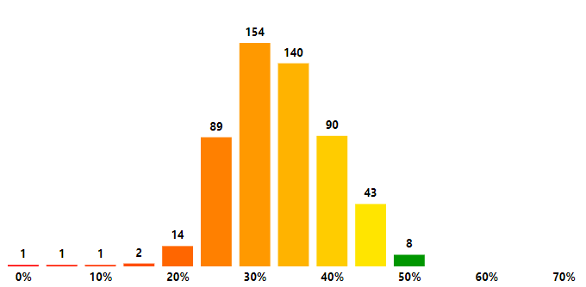 India’s **multi-party** polityand the **First past the post** system followed for the parliamentary general elections allows candidates who do not possess the majority mandate of the electors and voters to become the elected representatives.

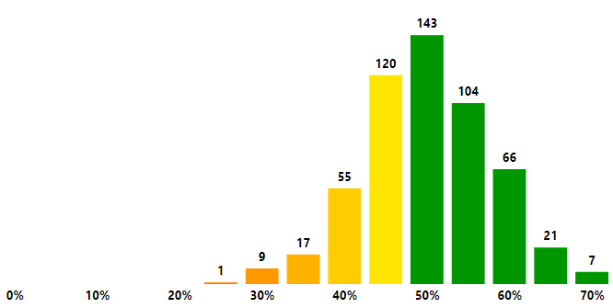**Fig.4: Distribution of constituencies on Electorate share of winners.**

**Fig.5: Distribution of constituencies on Voter share of winners.**

**Key Observations**

* **Electorate Share:**
  + From **Fig.4** we can infer that in only **8 constituencies** the elected candidates secured **more than 50% votes of the total electorate**.
  + This implies that the remaining **535** elected candidates may not be the most preferred candidates for the electorate of that constituency and hence the **outcomes cannot be considered fair.**
  + Further, it is seen that most of the winning candidates had an electorate share in the range of **30%-35%.** Cumulatively, the **average electorate share** of the elected candidates at the National level is **35.6%**.
* **Vote Share:**
* It can be derived from **Fig.5** that in only **341 constituencies** the elected candidates secured **more than 50% of the votes polled.**
* This indicates that the remaining **202** elected candidates may not be the most preferred candidate for the voters of that constituency and thereby making these outcomes **unfair**.
* Further, it is observed that most of the winning candidates had an electorate share in the range of **50%-55%.** Cumulatively, the **average vote share** of the elected candidates at the National level is **52.5%.**

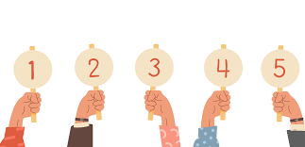

**Possible reasons**

The reasons for unfair electoral outcomes in most of the constituencies are **low voter turnout** rates and the **first past the post** system adopted at the time of Independence in 1947 considering the **low literacy rate6** (approx. 18% as per 1951 census) of the population.

**Suggestions**

The literacy rate of the country has increased gradually and stands at **74%** as per 2011 census**7**. In addition, even most of the illiterate are aware of the political happenings in the country due to increased penetration of the communication and broadcasting networks.

Therefore, it is time for the ECI to introduce **preferential voting** by means of **single transferable vote method** for the general elections as well, where the voters can rank the candidates in the order of their personal preference and the **most preferred candidate** is declared as the winner by transferring the votes of the least preferred candidates to the remaining candidates after every round of counting.

This system is already being followed for electing the President, Vice-President, Members of Rajya Sabha and Members of the Legislative Councils of the States.

**3.** **Gender of the Elected and Nominees**

India being a **multiparty democracy** where the electors and voters have multiple choices to choose among the contestants, it is essential to look at the gender inclusiveness of the choices as well to understand whether every gender is adequately represented in the decision-making process at the highest level.



**Fig.8: Gender break-up of the Nominations filed**

**Fig.9: Gender proportion of the Elected Representatives**

**Fig.9: Gender of the Elected representatives of all constituencies**



**Key Observations**

**Vote Share to nominees by g**

**Key Observations**

* **Gender of the Nominees:**
* A total of **8054** nominations were filed for the 2019 general elections at an average of approximately **14** nominations per constituency.

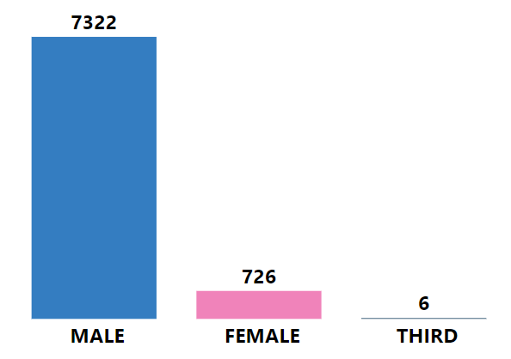

**Fig.8: Nominations filed by each gender**

* **Fig.8** shows the count of nominations filed by each gender and this shows a huge **disparity in participation** among the genders with respect to their populations.

The above data can be further translated as follows in percentage terms.

* + **Male** nominees are **90.9%**
  + **Female** nomineesare **9.01%**
  + **Third Gender** nomineesare **0.074%**
* **Voter share of the contestants by Gender:**
* Total no. of votes and vote share of contestants of each gender is as below.
  + **Male** contestants share is **86.5%** or **52.57** crore votes.
  + **Female** contestants share is **13.5%** or **8.19** crore votes.
  + **Third Gender** contestants share is **0.003%** or **17,094** votes.

The above data indicates that **male contestants were more preferable** than other genders as elected representatives.

* 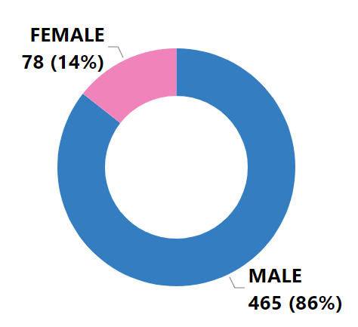**Proportion of seats won by Gender and their success rate:**

**Fig.9 Seats won by each gender**

* **Fig. 9** proves that the gender proportion of the members of Lok Sabha is **not representative of the populations of genders** and is highly skewed towards males
* The **success rate** of the contestants by gender is given below**:**
  + **Male** contestant’s success rate is **6.35%.**
  + **Female** contestant’s success rate is **10.75%.**
  + **Third Gender** contestant’s success rate is **0%.**

**Possible reasons**

The reason for disproportionate participation rates of **female contestants and third gender contestants** can be pointed to following two reasons.

1. The deeply ingrained gender roles in the Indian Society have **traditionally positioned women as homemakers**, responsible for household duties and childcare, while for individuals identifying as third genders, **societal acceptance** remains a significant challenge.
2. **Reluctance of major political parties to nominate females and third-gender individuals** as their candidates in elections, often leaving them with no option but to run as independent candidates. Unfortunately, this poses a significant challenge to their electoral prospects since **voter behaviour** tends to be heavily influenced by party affiliations

**Suggestions**

To truly achieve gender inclusivity in the Indian Political landscape we must **reserve significant number of constituencies** **for both females and third genders,** similar to what is done for SC and ST communities, thereby stimulating their political interests and aspirations.

The recent **108th amendment to the Indian Constitution**, **reserving 33% percent of seats for women7**, is a significant step in this regard and its implementation shall mark the beginning of a new chapter in the Indian Constitutional journey. A similar move is required for the third genders also in proportion to their population, ensuring them representation at the highest level of decision-making process.

**4.** **Age of the Politicians**

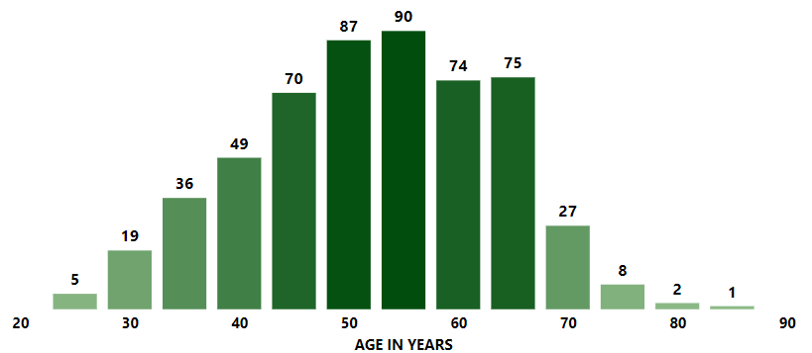 India's vibrant young population underscores the critical need to examine the political involvement of this demographic, as they are poised to emerge as the future leaders of the nation. The age distribution of the elected and the nominees is as follows.

**Fig.10 Age Distribution of the elected candidates**

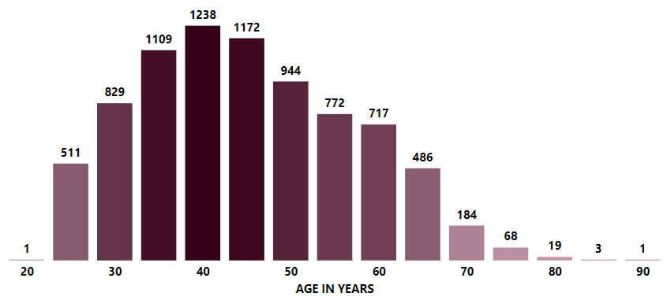**Fig.11 Age Distribution of the nominees**

**Key Observations**

* **Elected Candidates:**
  + **Fig.10** indicates that a significant portion of the elected members lie in the age bracket of 50 to 60 years with a **median age** of **55 years** signifying that the electors are more inclined towards the contestants who have years of **political experience** behind them.
* the median age of **female** members is **49 years**, indicating that female candidates, on average, are younger than their **male** counterparts whose Median age is **56 years.**
  + It is noteworthy that more than **100 elected** members are **below 40 years** of age signifying the presence of young members in the parliament.
* **Nominated Candidates:**
  + **From fig.11,** it is evident that most contestants are in the age bracket of **35-50 years** with a **median age** of **46 years** suggesting that the youth participation in politics surpasses that of the older population underscoring their strong political and leadership aspirations.
  + Median age of the contestants by gender as presented below shows that the third gender and female contestants are relatively younger than the male contestants.
  + Median age of **Male** contestants is **46 years.**
  + Median ageof **Female** contestants is **42 years.**
  + Median ageof **Third gender** contestants is **35 years.**

**Possible reasons**

The challenges faced by youth aspiring to pursue a career in politics are as follows.

* **Lack of Financial Resources**:

Young individuals may find it difficult to compete with seasoned politicians who may have access to more funds or a network of donors.

* **Difficulty Securing Party Tickets:**

Major political parties often prefer candidates with a track record in politics and a loyal voter base. Young people may struggle to secure party nominations because they lack experience and may be seen as less electable by party leaders.

**Suggestions**

Implementing **campaign finance reform measures** can help level the playing field by limiting the influence of money in politics. This may involve setting caps on campaign spending, requiring transparency in political donations, and providing public funding for campaigns.

**Political parties** should consider **internal reforms** to be more inclusive and open to younger candidates. Encouraging party leadership to mentor and support youth candidates can help bring fresh perspectives into politics.

Ultimately, addressing these challenges requires a commitment from both political institutions and society at large to create a more inclusive and equitable political landscape that welcomes the participation of young individuals with diverse backgrounds and ideas.

**Conclusion**

In conclusion, the analysis reveals a multifaceted landscape with both strengths and weaknesses. As the world's most populous democracy, India's governance and electoral processes hold global significance. In addressing these challenges, India can strengthen its democracy, ensuring that the electoral process truly reflects the will and diversity of its citizens. Reforms, inclusivity measures, and increased public awareness are critical steps toward creating a more equitable and representative political system in the world's largest democracy. By nurturing a vibrant and inclusive democracy, India can continue to set an example for the world in the years to come.

**References**

1. <https://www.worldbank.org/en/country/india>
2. <https://legislative.gov.in/constitution-of-india/>
3. <https://eci.gov.in/files/file/9315-the-representation-of-people-act-1951/>
4. <https://eci.gov.in/delimitation-website/delimitation/#:~:text=Delimitation%20literally%20means%20the%20act,Commission%20or%20a%20Boundary%20Commission>.
5. <https://web.archive.org/web/20201018124947/https://main.sci.gov.in/jonew/judis/41411.pdf>
6. <https://archive.pib.gov.in/archive/releases98/lyr2003/rsep2003/06092003/r060920031.html>
7. <https://www.census2011.co.in/literacy.php>
8. <https://prsindia.org/billtrack/womens-reservation-bill-the-constitution-108th-amendment-bill-2008-45#:~:text=Highlights%20of%20the%20Bill,authority%20as%20prescribed%20by%20Parliament>.